ACTIVITY DIAGRAM SPECIFICATION

ONLINE CLOTHING STORE SYSTEM
Online Clothing Store
DGM-05
The checkout activity flow, payment decision point, and success or failure branches.
Version 1.0
September 30, 2026
UEF SHOP

Activity Diagram Specification
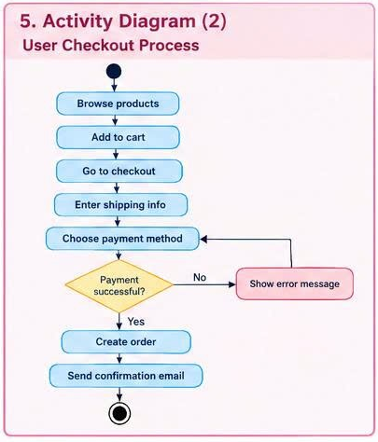
Figure 1. Activity Diagram for the Online Clothing Store system

Objective
The Activity Diagram describes the checkout flow from product browsing until the system creates an order and sends a confirmation email. The Payment successful? decision separates the success and failure paths.

Activity Flow
Step | Activity Node | Responsible Party | Result
A0 | Initial node | System | Start the shopping session.
A1 | Browse products | Customer | The Customer views the product list or product details.
A2 | Add to cart | Customer | The product, size, and quantity are added to the cart.
A3 | Go to checkout | Customer | The system opens the checkout process and validates the cart.
A4 | Enter shipping info | Customer | The delivery address and phone number are recorded.
A5 | Choose payment method | Customer | COD, card, or e-wallet is selected.
D1 | Payment successful? | System | Evaluate the payment confirmation result.

Step | Activity Node | Responsible Party | Result
A6 | Create order | System | Order, OrderItem, and Payment records are saved, and inventory is updated.
A7 | Send confirmation email | System | Order information is sent to the Customer.
A8 | Final node | System | Complete checkout successfully.

Decision Branches
Guard | Condition | Destination
[Yes] | The Payment Gateway confirms success or COD is accepted. | Create order → Send confirmation email → Final node.
[No] | The transaction is declined, times out, or contains invalid payment data. | Show error message -> return to Choose payment method.

Conditions and Exceptions
Preconditions | The product page is operational; Product and inventory data are accessible.
Success Postconditions | The order is created once, the cart is cleared or marked as checked out, and confirmation is sent.
Failure Postconditions | No Order is created; the cart and delivery information are retained so the Customer can try again.
Inventory Exception | If a product is out of stock at A3 or A6, return to the cart and require the quantity to be adjusted.
Delivery Data Exception | If A4 is missing a required field, do not proceed to A5 and display an error beside the field.
Retry Limit | After repeated payment failures, the system still does not create an order and may require the Customer to select another method.

